**CDA4630**

**Dr. Bassem Alhalabi**

**Fall 2016**

**MGM Home**

**Automation**

**Submitted By**

**Group 1**

**Mohammed Alsanea**

**Garvin Casinillo**

**Michal Hus**

**Introduction**

MGM home automation has two goals, the first is to automate mundane household tasks individuals and the second is to improve home security. Our project will implement two home automation features; it will turn on a fan when the temperature sensor determines that the room is too hot and it will also use a motion sensor that will turn on a lightbulb when any motion is sensed. Our project improves home security by using a password enabled keypad that turns on a servo which will open a door.

***Components***

In order to achieve our objectives, we will be using the following components during our implementation:

1. PIR sensor
   1. Model Number: HC-SR501
   2. This component will be featured as part of the home automation project and will be used to detect motion.
2. Temperature Sensor
   1. Model Number: MCP9701-E
   2. This component will be implemented as part of the home automation portion of the project and will be used to measure the temperature in the room.
3. Micro Servo
   1. Model Number: Tower Pro 9g
   2. This component is part of bot the home automation and the security portion of the project and will be used to simulate the door opening and closing.
4. Keypad
   1. Model Number: Grayhill Series 96 Keypad
   2. This component is part of the security system and will be paired with the servo. If the correct password is entered into the keypad then the servo will be activated, otherwise the servo will not move.
   3. The keypad will also be able to reset and create a new password.
5. Microcontroller
   1. Model Number: TI MSP430
   2. This component will be the microcontroller that will control the system and implement any and all functionalities.

***Design and Implementation***

The object of our design is to create a compact circuit that will contain the components that will implement the security and automation features that we want. Furthermore, our design will require that all the components will work in a cohesive manner so that all the functionalities we wish to implement will be executed properly. However due to the constraints of the project we will use LED’s as a substitute for the fan and the lightbulb that are part of the temperature and motion sensor circuit. Furthermore, the servo we are using is a smaller and less powerful than commercial grade servos that would be used in home applications, but even with these substitutions scaling up our project into a fully functioning product will not be a problem.

The temperature sensor we are using will be implemented as having one input and one output. The input will use an analog to digital conversion pin, while the output will be used to drive an LED. The PIR sensor will also be implemented in a similar manner with one input and one output. The input will use a pin that has the capability to implement an interrupt and the output pin of the PIR will be used to power an LED. The keypad will use a total of eight pins, four of which will be set as input pins and will use interrupt enabled pins. The other four pins will be set as output pins and will use pins that cannot implement any interrupts. The four input pins will be used to read the columns and the four output pins will be used to read the rows of the keypad. The servo will take up one pin from the microcontroller and will serve as an output when the correct password is entered into the keypad. Finally, at the center of our design is the MSP430 microcontroller which will control all of the functionalities of these components.

**Task Assignment**

All of the project features were done with evenly distributed workload and effort from all group members. We met twice a week for during the duration of the implementation period of this project. However, the workload was separated with Michal Hus working on the keypad. Mohammed Alsanea implemented the servo and Garvin Casinillo worked on the PIR sensor. However, Mohammed also helped Michal with the keypad and Garvin and Michal worked together to implement the temperature sensor. After all the components were implemented separately we worked together to integrate the circuit and the code.

***Challenges***

During the course of the implementation our group encountered two major challenges, first was the keypad and the second was the overall integration of the circuit. The keypad took the most time since we were unfamiliar with the logic needed to implement the correct code. Mostly we used trial and error in trying to overcome this challenge, however it was not until we got proper guidance from our professor that we finally got the correct logic and overall knowledge to implement the keypad. The other key challenge that we faced was the integration of all the components into one circuit that uses a single MSP430 microcontroller. During the initial stage of our implementation each team member independently implemented a different functionality, which resulted in different components being implemented separately, each with their own microcontroller and breadboard. Our first major hurdle with this challenge was physically extracting each component from their respective circuit and combining everything into one circuit and using one microcontroller. Afterwards the second difficult task with full scale integration came with combining all of our code. This took the most time since we had to figure out a way for the various variables and interrupts to work together. In order to achieve this, we had to carefully integrate one functionality at a time and in some cases we had to add one line of code at a time until we were able to combine all of the functionalities in one code.

Even after overcoming these challenges we still had a problem with the temperature sensor working together with the keypad and the servo. Whenever the keypad is used to turn on the servo the LED that is being controlled by the temperature sensor would blink uncontrollably. In order to solve this issue we opted to add a *clear* functionality to the keypad that would reset the servo so that the LED controlled by temperature sensor will stop blinking.

**Circuit diagram**

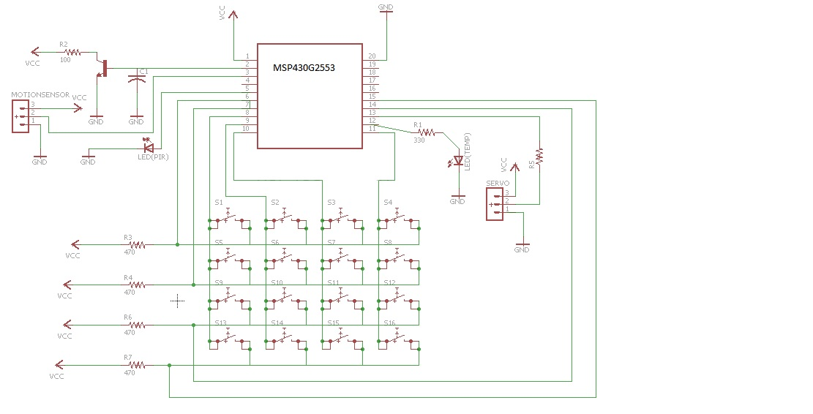

**Algorithm Flowchart**

***Main Flowchart***

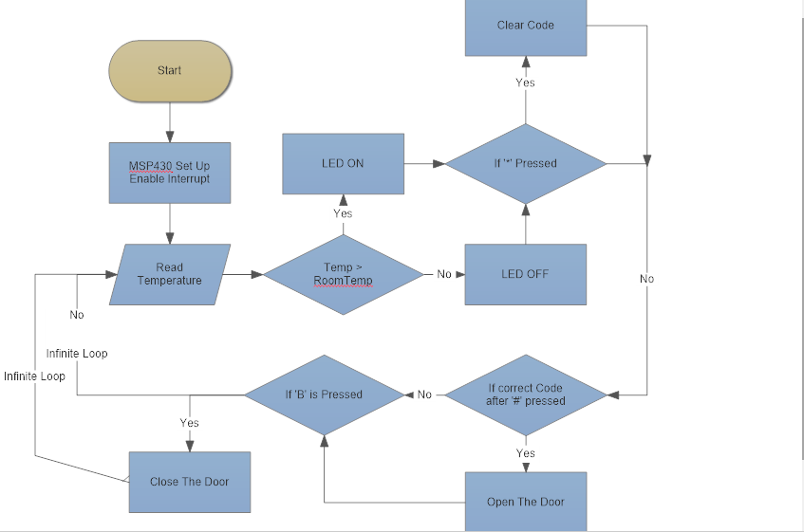

***Interrupt Flowchart***

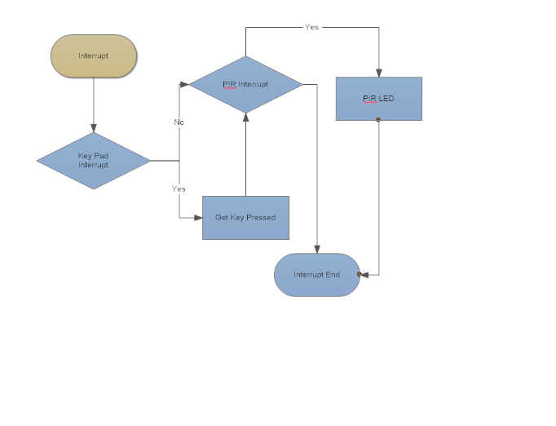

**Final Product Design**